AWAITINGTHENWAJIUBAPHENOMENON(1)

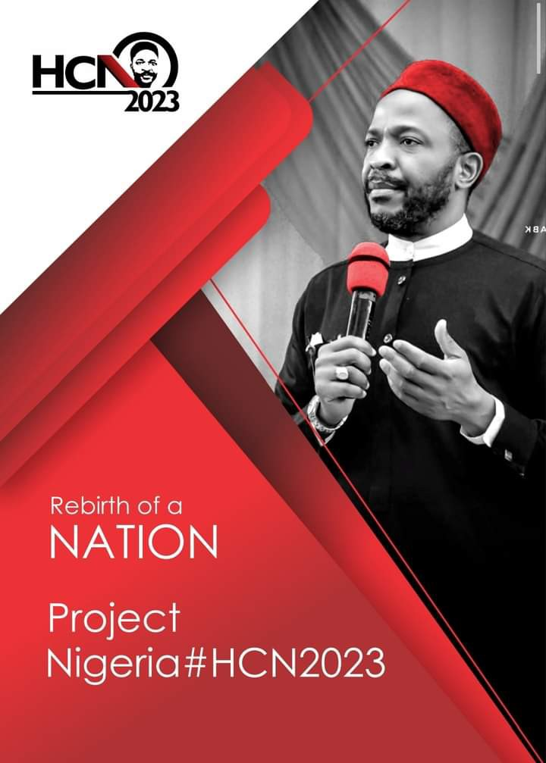

-PASCHALEGERUE.

Nigeriaisat it's most challenging timesinceher independence in1960.Thesovereigntyof the countryisbeingchallengedbyalotofnonstateactors,posingasterrorists,bandits,kidnappers and armed robbers. The impetus for this development is the noticeable weaknesses in our institutionsandthelawlessnessbredbytheseweaknesses.Patrioticcitizensofthiscountryare called to action and duty to choose the next President of Nigeria. We need an entirely new President,youthfulenoughtochallengethestatusquo,fearlessenoughtomakesecurityoflives and property of citizens the primary duty of government and humble and pan Nigerian enough toget allhandsondecktoensurethatthesovereigntyofNigeriais not violatedbyanyperson. Theskillsetforthiscriticalinterventionisbeyondthatofourconventionalpoliticianssteepedin prebendal politics that has brought this country to her knees. Nigeria at this juncture needs a pragmaticmiddleagedpersonwithoptimalhealth,energy,panNigeriansocialnetworkoutlook and competitive knowledge of how the local and global economy works. We need a President that will stand eyeball to eyeball with world leaders to negotiate from a position of sound knowledge,whatisinthebestinterestofNigeria.ThepositionofthePresidentofNigeriashould notbeatrivialmatterofsatisfyingthepersonalaspirationandfancyofthosewhomerelywant it just toaddit to theirCV.It shouldtherefore not be for sale tothe highest bidder.Weare in a war situation and a smart versatile leader is required. The years of experimentation are gone. Let us rebuild Nigeria. As 2023 beckons, there is every reason to look to the direction of Hon(Dr)Emeka Nwajiuba as the next President of Nigeria. He has the humility, dynamism, selflessness, dedication and loyalty to serve. He has been tested with very significant federal assignmentsonwhichheperformedexcellentlywellandwithoutblemish.Heisastrongbridge
linking the youths and the elders, the north and south and the corporate world and the political class. Even though he is power packed with knowledge, Hon(Dr) Emeka Nwajiuba has this disarminghumilityanddedicationtoserveandtobeheldaccountableonhisfunctions.Heisa secureleaderthatwillassembletimely,theneededtechnocratstobringbackthiscountryfrom the brinks and reposition her as the giant of Africa. It is very important that the ruling party embrace the Emeka Nwajiuba phenomenon ahead of the party's convention. This ofcourse is thesurewayAPCcanretainpowerin2023andbeyond.Retainingpowerin2023byAPCshould be important to the incumbent President and should be rated higher than any other consideration. Dr Emeka Nwajiuba is surely the answer. Any other option will amount to dangerousgamblingthatwillsendtheAPCoutofpower.

PaschalEgerueisaLagosbasedInsuranceandmanagementconsultant.

